myKindy at Victory College

173 Old Maryborough Road

Philosophy

2025

**Our Educational Program**

Our educational program is child led and based on their interests. Our chid centred approach to curriculum is designed to build on the children’s unique needs, interests, and strengths of each child. Our program supports children to make choices and to be involved in the decision making and support children to develop self-help skills, independence, and responsibility.

Our program is aligned with the Queensland Kindergarten Learning guidelines and the foundations of the principles and practices of the Early Years Learning Framework. It is designed to support teachers to plan and implement quality teaching and learning. Our play-based program allows for expression and curiosity and offers the opportunity for the children to explore and discover their world. In play we respond to their ideas and interests, guiding their learning as we take those spontaneous learning opportunities for teachable moments. As educators we are intentional in all parts of the curriculum and are thoughtful and purposeful in our planning for the children.

The Early years Learning Framework plans for children’s learning based on 5 learning outcomes and the Queensland Kindergarten learning Guidelines are closely aligned with these 5 learning outcomes which include:

1. Identity
2. Connectedness
3. Wellbeing
4. Active Learning
5. Communicating

Assessment is strength based and ongoing of gathering information, analysis and reflecting on evidence of learning.

We encourage positive dispositions for learning through a variety of intentional teaching practices including:

* Providing stimulating and inviting experiences for provocations to encourage children to create and explore.
* Encouraging children to be active participants in their learning by allowing them to make decisions, share their ideas in the program and develop and understanding of themselves and their world through active hands-on learning experiences.
* Supporting them to be capable, confident, and involved learners, responding to their ideas and interests and guiding their learning through scaffolding and engaged conversations.
* Role modelling and being responsive to children’s play ideas, showing interest, enthusiasm, and encouragement.
* Creating a play space for children to ask questions, solve problems and engage in critical thinking.
* Setting environments for inquiry-based learning.
* Rich engaging environments and meaningful interactions where children’s voices are listened to, and the program is child led.
* Building children for Success and lifelong learning.

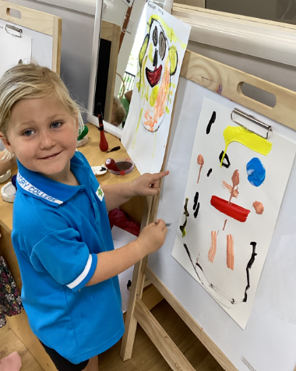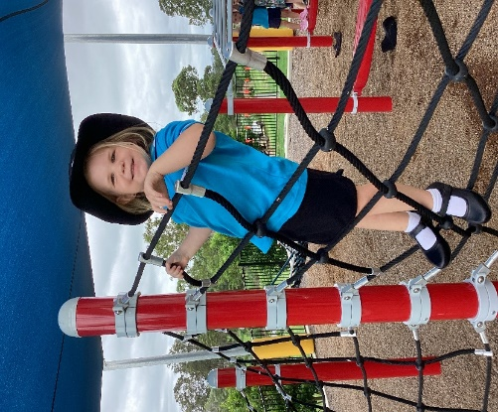

**Christian Faith**

Our aim is to provide a safe and nurturing Christian environment promoting Christian values through positive Christian example and through a Christ centred educational program. myKindy as part of Victory college is an outreach arm of Victory Church. The church has a vision to provide care and service based on Christian beliefs, values and ethics. Christian education plays a vital role in teaching the children about God, instilling biblical values, nurturing spiritual growth, and preparing the children to live as faithful followers of Jesus Christ.

We do this by:

* Teaching the children about prayer and embedding it in our daily routine.
* Expressing our faith and teaching children that when we pray, we express our faith in God
* Introducing Bible stories to teach children about key figures, events, and teaching of the Christian faith.
* Creating an environment showing love in our interactions with each other to exemplify the love of Christ.
* Participating in Religious celebrations and nurturing our vibrant faith community.
* Attending Chapel and celebrating through songs and Christian Faith messages and values such as Honesty, Kindness, forgiveness, and faith.
* Celebrating “Fruits of the Spirit” which are love, Joy, peace, Patience, Kindness, gentleness, and self-control.

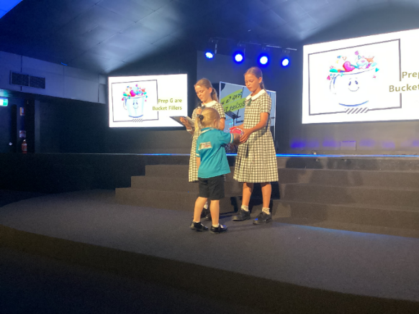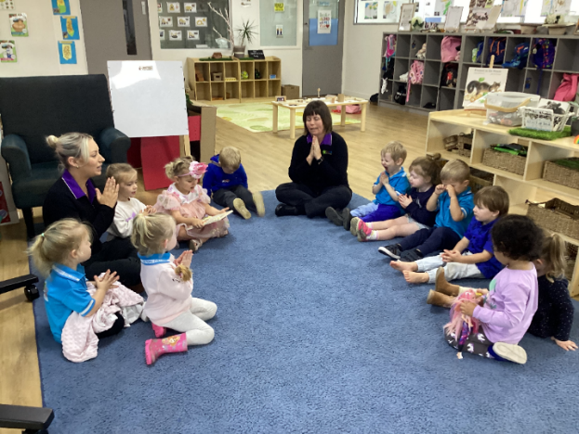

**Family Partnerships & Community Connections**

Our underpinning philosophy is to nurture the partnership between church, College, Kindergarten and Family. It is important for us to acknowledge the diversity of our families and know their aspirations for their children. We aim to work in partnership with our families and establish a sense of community where both children and families feel welcomed and are encouraged to engage in shared decision making to support the children’s learning and wellbeing.

We understand that connecting with the community is essential to children’s learning and supports social connections and a feeling of belonging. We extend the children’s learning while supporting their interests through incursions and excursions.

We support family partnerships and community connections by:

* Building Connections between the early childhood setting and the local community.
* Being a part of the Victory College School community and Church
* Strengthening the child’s home to kindy connections involving family participation and celebrating meaningful events i.e., Anzac Day, attending Chapel, Visiting our Local Bunnings Store, Mother’s Day, Grandparents Day.
* Encouraging families to participate and contribute to our daily program
* Encouraging reciprocal feedback between families and the service.

**Secure and Respectful Relationships**

At myKindy we pride ourselves on our genuine relationships we have with our children and families. We believe that nurturing relationships create a trusting and educational space for the children and provide them with consistent emotional support throughout their development. We are in tune to the needs of the children and understand it is important to actively listen to them so that we are able to respond to their needs.

We believe in taking a holistic approach in supporting children in their cognitive, physical, social, emotional, personal, and spiritual growth. We aim to develop personal value and attribute such values as honesty, resilience, empathy, and respect for one another. We believe it is important to teach the children to respect each other and interact positively with each other.

We build upon relationships and educators support this by:

* Being warm, caring, and responsive
* Encouraging social competence, language development and resilience as we support children in their relationships with others, to make friends and care for others
* Building connections and encouraging children to play, learn and explore
* Showing patience, gentleness, and reassurance for children’s sense of security.
* Ensuring children feel valued and belong ie, celebrating birthdays

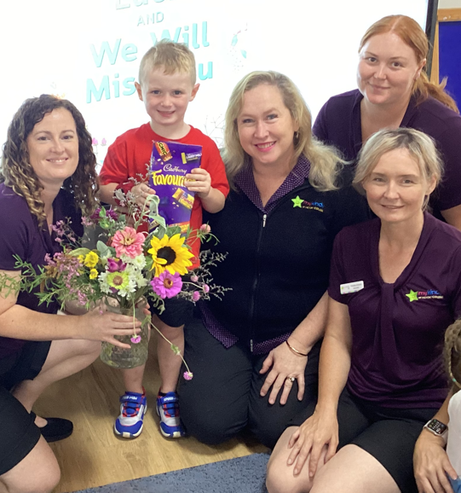

**Respect for Diversity, Culture & inclusiveness**

We aim to promote a greater understanding of Aboriginal and Torres Strait Islander culture and respect for different backgrounds and cultures. Our Program provides opportunities for children to learn about similarities and differences and about interdependence and citizenship. We are committed to the values of equality and justice and embedding Aboriginal Torres Strait Islander perspectives. We will continue to demonstrate an ongoing commitment working collaboratively with culturally and linguistically diverse children and families of mykindy.

We pride an inclusive environment to provide access, participation, and engagement in learning for all children in our care regardless of their capabilities, gender and children experiencing barriers. We work closely with local support agencies like inclusion Support who assist us with our Services Inclusion Plan.

We aim to strengthen our knowledge on Aboriginal and Torres Strait Islander culture through:

* Building genuine partnerships with Local Aboriginal and Torres Strait Islander people and communities.
* Showing a deep respect for Elders and traditional custodian of the land through teaching the children about “Acknowledgement of Country”.
* Ensuring we are culturally responsive in our curriculum planning and offering the children opportunities to explore cultures through stories, art, music, dance and offering cultural studies within our program, called Gandan Yarning’s.
* We will commit to developing and actioning a service reconciliation action plan.

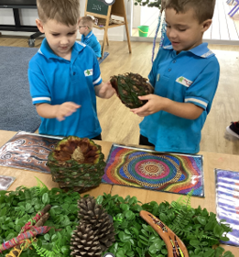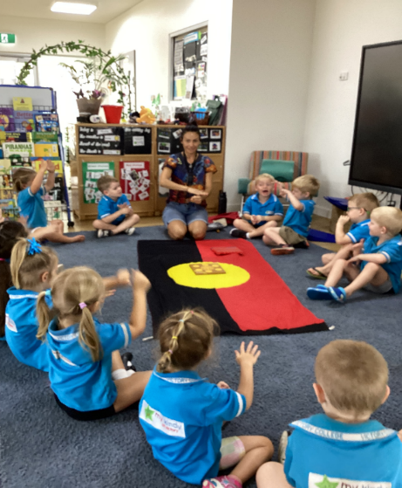

**Learning Environments & Sustainability**

myKindy prides ourselves on our environments both indoor and outdoor with a natural play space where children have the opportunity for physical play, challenge and to also explore natural elements. We place value on the children being able to be connected to nature and explore their outdoor surroundings. Our environments are flexible and forever changing to accommodate the needs and evolving interests of the children.

We aim to provide a happy, healthy, and safe environment as we adhere to the regulatory requirements to ensure the physical environment is safe as practicable and supervision is a high priority.

Mykindy is committed to protecting and teaching the children about environmental issues with a sustained focus on caring for our world and all its creatures. We believe it is important to make changes and teach children about being sustainable for a better future. we will encourage the children to develop an appreciation of the natural interaction between people, animals, and plants.

Our educators promote sustainable practices by:

* Promoting the 3 R’s, Reduce, Re-use and Recycle
* Re-use and re purpose material for play
* Educators encouraging interest and participation in planting activities, caring for our garden and the natural environment.
* Role modelling and talking with the children about energy and water conservation. Role model these behaviours for example, encouraging the children to turn of the tap after washing their hands.
* Educating the children how to care for pets and animals
* Learning about food scraps and decomposition. Involving the children in daily practices, feeding the worms and chickens.

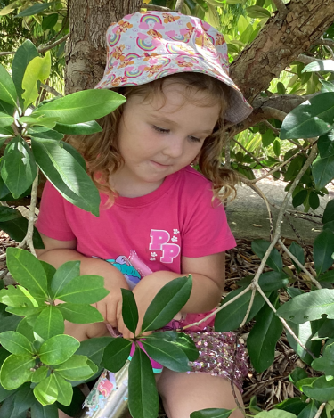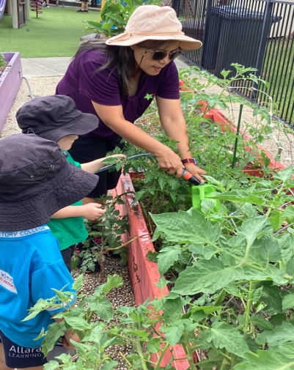

**Professional Learning & Leadership**

**“Leadership is enacted by individuals and teams as one connects with one another to make changes that reflect a shared vision and purpose” (Lewis and Hill, 2012)**

myKindy reflects a positive work and team culture. We engage in professional conversations about our practices and continually reflect on our practices both individually and as a team. Our educators are committed to contributing to our curriculum decisions and our services Quality Improvement Plan. We are continuously seeking to build our knowledge and skills.

We adhere to the Code of Ethics and under the guidance of our Christian beliefs, always act in the best interest of all the children to ensure that every child is thriving and learning. The National Quality Standards reflect Australia’s commitment to the United Nations Convention on the Rights of the Child and obligations of all those work with Children to protect children from harm, respect their dignity, provide a safeguard, and promote every child’s wellbeing.

We aim to promote effective leadership by:

* Seeking out the perspective of others
* To always deepen our understanding of our practices, to examine and explore new ideas through critical reflection
* Ensure Children’s learning, development, with wellbeing a core focus.
* Collaboratively developing a culture of ethical inquiry and a cohesive and effective team
* Regular staff meetings and professional development opportunities, keeping abreast of regulatory training i.e. First Aid Training and Child Protection
* Supporting educators with their professional goals.
* Upholding Victory College values.
* Embedding the traditional values drawn from our Australian Christian heritage within our learning environment. Our educators model these values through relationships, conduct, presentation, and work ethic.
* Developing our Christian Faith in God, upholding the mission and values of the college, understanding, Honour, Faith, Service and Excellence.

